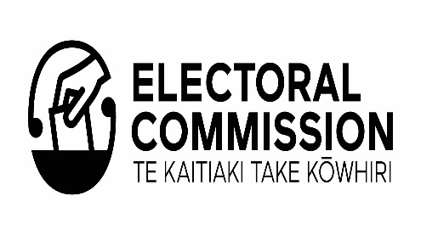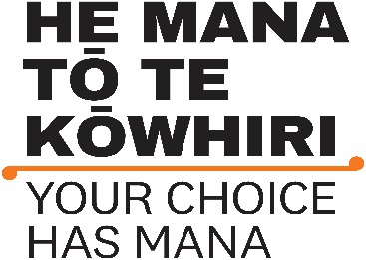

He Mana tō te Kōwhiri – Your Choice has Mana
Māori Electoral Option - Te Kowhiringa Pōti Māori

What is the Māori Electoral Option?
The Māori Electoral Option is a choice for Māori about which electoral roll they want to be on: the Māori roll or the general roll.

When can you choose rolls?
If you are Māori, and enrolling for the first time, you choose which electoral roll you want to be on.
You can also change your roll type at any time, except:
- in the 3 months before a general election;
- in the 3 months before local elections which are held every 3 years;
- before a parliamentary by-election if the change would move you into the electorate where the by- election is being held.

What does your choice mean for you?
Your roll choice affects which candidates you can choose from in parliamentary elections and local elections.

Voting in parliamentary elections and by-elections
- If you choose the Māori roll, you will vote for a candidate in the Māori electorate you live in.
- If you choose the general roll, you will vote for a candidate in the general electorate you live in.
- You can vote for the same list of political parties in a general election, whichever roll you choose to be on.
The roll you choose may influence the number of Māori and general electorates for parliamentary elections. The number of Māori enrolled on the Māori roll could mean that the number of Māori electorates increases, decreases or stays the same.
Your choice will also help determine the boundaries of Māori and general electorates when they are reviewed.
The next boundary review will happen before the 2026 General Election.

Voting in local elections
The roll you choose may affect who you can vote for at local elections.
If you choose the Māori roll, and your local council has a Māori ward or constituency, you will vote for candidates in the Māori ward or constituency. If you choose the general roll, you will vote for candidates in the general ward or constituency.

What is an electorate?
New Zealand is divided into voting areas called electorates. When you enrol to vote, you’re enrolled in the electorate where you live.
New Zealand has two types of electorates: Māori and general. At a general election, a member of Parliament (MP) is elected to represent the people in each electorate.
Everywhere in New Zealand is covered by both a Māori electorate and a general electorate.
While electorates are not always the same size, they each have roughly the same number of people in them.

What is a local council ward or constituency?
A ward or constituency is a council voting area, like a parliamentary electorate. City and district councils have wards, and regional councils have constituencies.
Some councils have both Māori and general wards or constituencies. At the local elections, councillors
are elected to represent the people in each ward and constituency.
While each voting area is not always the same size, they each have roughly the same number of people in them.

There are currently 7 Māori electorates and 65 general electorates
The roll you choose decides which electorate you vote in.
For example, if you live in Rotorua and choose the Māori roll you will vote in the Waiariki electorate.
The person who wins the most votes in the Māori electorate of Waiariki will become your local MP.
If you choose the general roll, you will vote in the Rotorua electorate. The person who wins the most votes in the general electorate of Rotorua will become your local MP.

How to make your choice
If you’re happy with the roll you’re on, you don’t need to do anything.
If you want to change the roll you’re on you can make the change online at vote.nz. You’ll need either a New Zealand driver licence, New Zealand passport or RealMe verified identity.
You can also change the roll you’re on by filling in a paper enrolment form. Call 0800 36 76 56 for free and ask for an enrolment form to be sent to you.

Unpublished roll
You can’t change your enrolment at vote.nz if you’re on the unpublished roll. Instead, you’ll need to fill in an enrolment form.

Enrol or change you roll online
You can enrol or change the roll you’re on at vote.nz using your New Zealand driver licence, New Zealand passport or RealMe verified identity.
Or you can fill in a paper enrolment form. Call 0800 36 76 56 for free, and ask for a form to be sent to you.

Help your community get enrolled to vote
Pass this information on to any of your whānau or friends who aren’t enrolled so they can make their choice too.

More information
For more information about the Māori Electoral Option or enrolling to vote:
- Visit vote.nz
- Call 0800 36 76 56

End of information: He Mana tō te Kōwhiri – Your Choice has Mana Māori Electoral Option - Te Kowhiringa Pōti Māori

